**MySQL Task**

*(using* [*sqlbolt.com*](https://sqlbolt.com/)*)*

**SQL Lesson 1: SELECT queries 101:**

**Exercise 1 — Tasks**

1. Find the title of each film ✓

* ***SELECT title FROM movies;***

1. Find the director of each film ✓

* ***SELECT director FROM movies;***

1. Find the title and director of each film ✓

* ***SELECT title, director FROM movies;***

1. Find the title and year of each film ✓

* ***SELECT title, year FROM movies;***

1. Find all the information about each film ✓

* ***SELECT * FROM movies;***

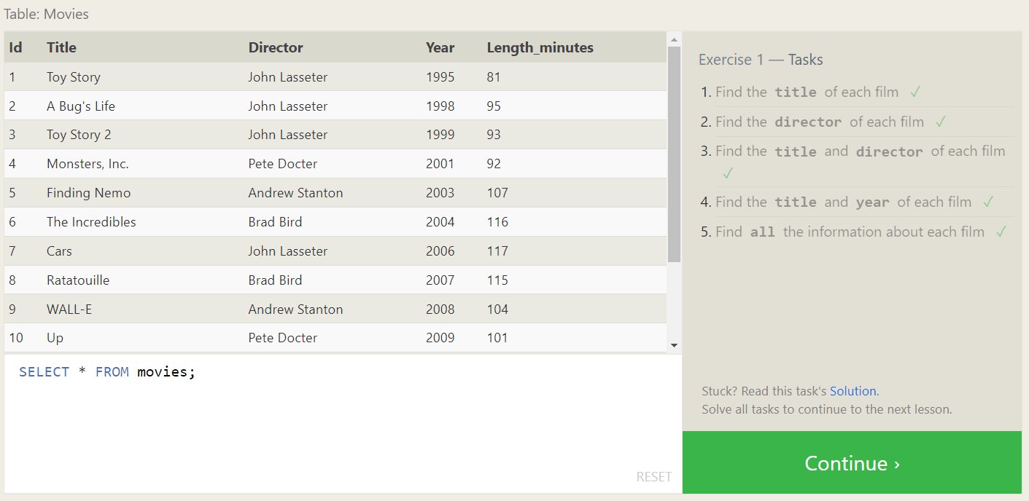

**SQL Lesson 2: Queries with constraints (Pt. 1)**

**Exercise 2 — Tasks**

1. Find the movie with a row **id** of 6 ✓

* ***SELECT * FROM movies WHERE id=6;***

1. Find the movies released in the **year**s between 2000 and 2010 ✓

* ***SELECT * FROM movies WHERE year BETWEEN 2000 AND 2010;***

1. Find the movies **not** released in the **year** s between 2000 and 2010 ✓

* ***SELECT * FROM movies WHERE year NOT BETWEEN 2000 AND 2010;***

1. Find the first 5 Pixar movies and their release ✓

* ***SELECT * FROM movies LIMIT 5;***

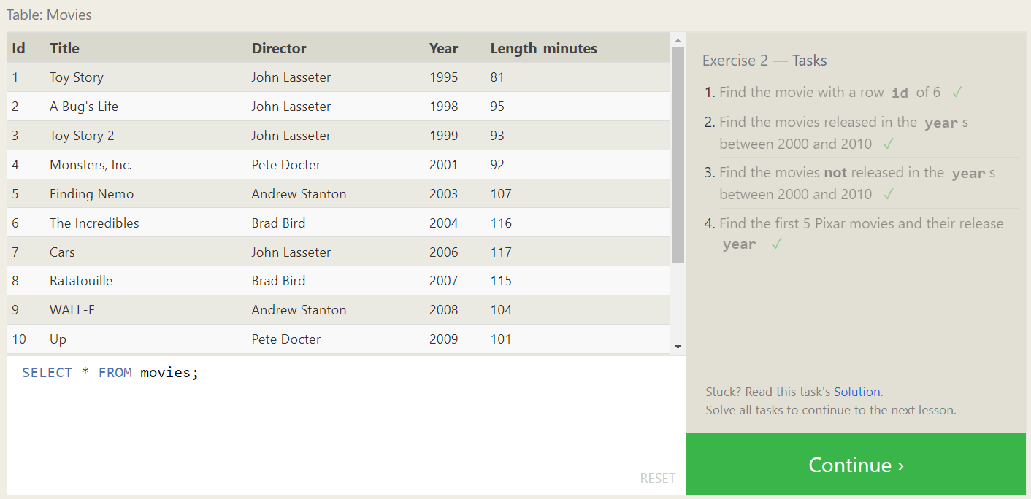

**SQL Lesson 3: Queries with constraints (Pt. 2)**

**Exercise 3 — Tasks**

1. Find all the Toy Story movies ✓

* ***SELECT * FROM movies WHERE title LIKE "%Toy Story%";***

1. Find all the movies directed by John Lasseter ✓

* ***SELECT * FROM movies WHERE director="John Lasseter";***

1. Find all the movies (and director) not directed by John Lasseter ✓

* ***SELECT * FROM movies WHERE director!="John Lasseter";***

1. Find all the WALL-* movies ✓

* ***SELECT * FROM movies WHERE title LIKE "%WALL-%";***

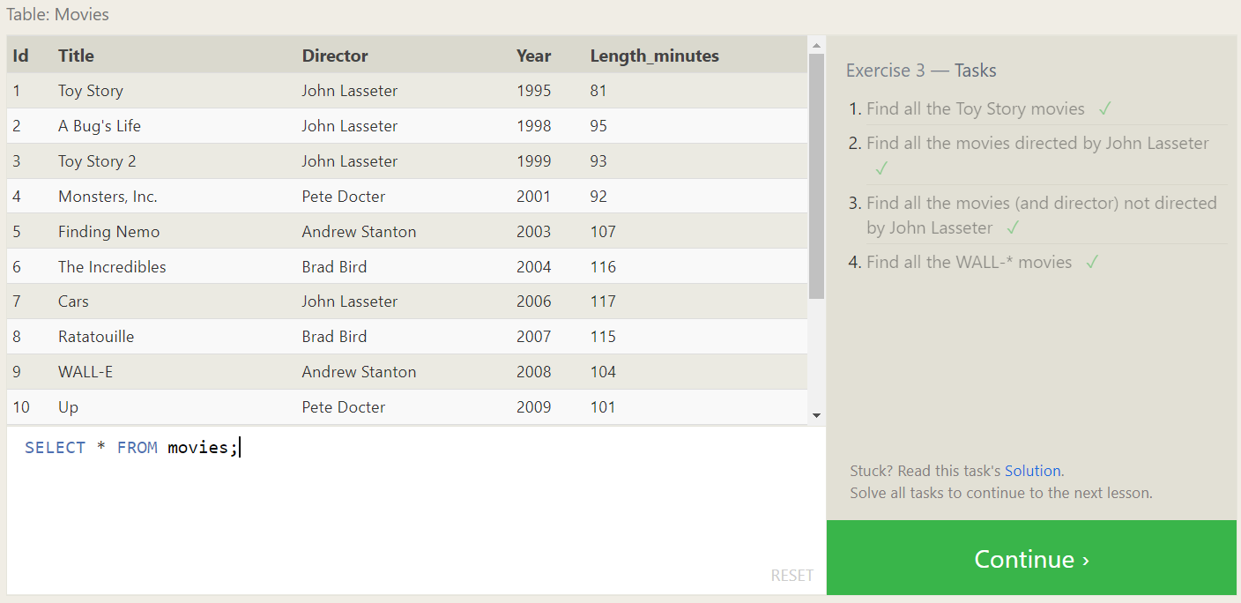

**SQL Lesson 4: Filtering and sorting Query results**

**Exercise 4 — Tasks**

1. List all directors of Pixar movies (alphabetically), without duplicates ✓

* ***SELECT DISTINCT director FROM movies ORDER BY director ASC;***

1. List the last four Pixar movies released (ordered from most recent to least) ✓

* ***SELECT * FROM movies ORDER BY year DESC LIMIT 4;***

1. List the **first** five Pixar movies sorted alphabetically ✓

* ***SELECT * FROM movies ORDER BY title ASC LIMIT 5;***

1. List the **next** five Pixar movies sorted alphabetically ✓

* ***SELECT * FROM movies ORDER BY title ASC LIMIT 5 OFFSET 5;***

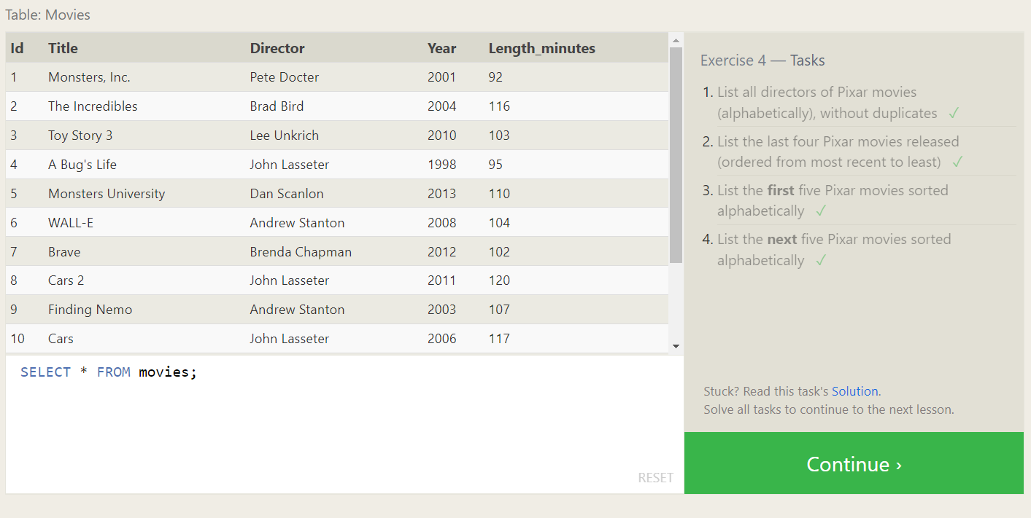

**SQL Review: Simple SELECT Queries**

**Review 1 — Tasks**

1. List all the Canadian cities and their populations ✓

* ***SELECT city, population FROM north_american_cities WHERE country='Canada';***

1. Order all the cities in the United States by their latitude from north to south ✓

* ***SELECT * FROM north_american_cities WHERE country='United States' ORDER BY latitude DESC;***

1. List all the cities west of Chicago, ordered from west to east ✓

* ***SELECT city, longitude FROM north_american_cities WHERE longitude < -87.629798 ORDER BY longitude ASC;***

1. List the two largest cities in Mexico (by population) ✓

* ***SELECT * FROM north_american_cities WHERE country='Mexico' ORDER BY population DESC LIMIT 2;***

1. List the third and fourth largest cities (by population) in the United States and their population ✓

* ***SELECT * FROM north_american_cities WHERE country='United States' ORDER BY population DESC LIMIT 2 OFFSET 2;***

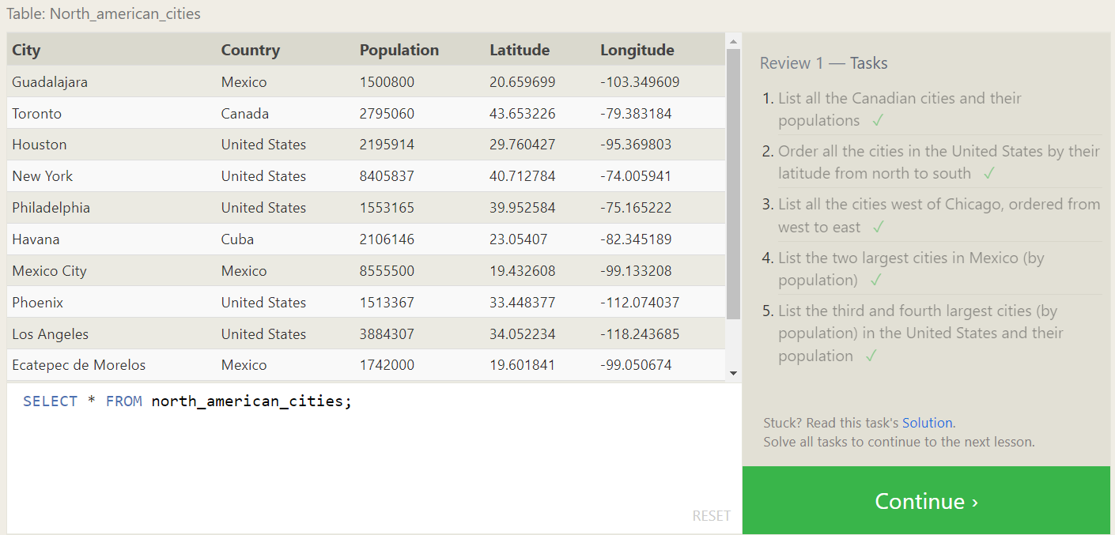

**SQL Lesson 6: Multi-table queries with JOINs**

**Exercise 6 — Tasks**

1. Find the domestic and international sales for each movie ✓

* ***SELECT title, domestic_sales, international_sales FROM movies INNER JOIN boxoffice ON movies.id = boxoffice.movie_id;***

1. Show the sales numbers for each movie that did better internationally rather than domestically ✓

* ***SELECT title, international_sales, domestic_sales FROM movies INNER JOIN boxoffice ON movies.id = boxoffice.movie_id WHERE international_sales > domestic_sales;***

1. List all the movies by their ratings in descending order ✓

* ***SELECT * FROM movies INNER JOIN boxoffice ON movies.id = boxoffice.movie_id ORDER BY rating DESC;***

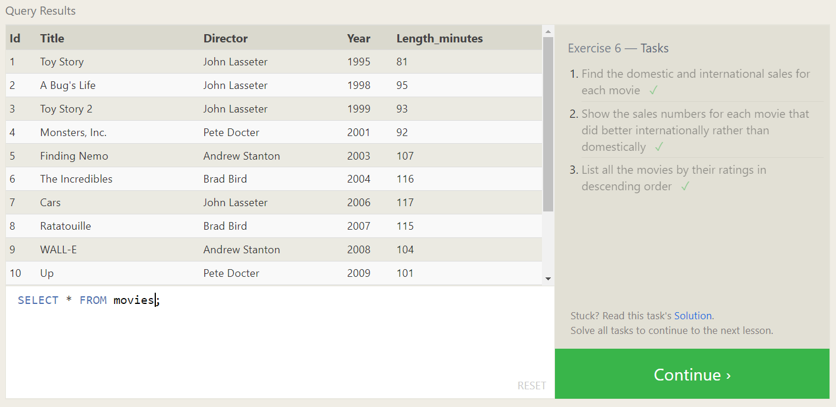

**SQL Lesson 7: OUTER JOINs**

**Exercise 7 — Tasks**

1. Find the list of all buildings that have employees ✓

* ***SELECT DISTINCT building FROM employees;***

1. Find the list of all buildings and their capacity ✓

* ***SELECT * FROM buildings;***

1. List all buildings and the distinct employee roles in each building (including empty buildings) ✓

* ***SELECT DISTINCT building_name, role FROM buildings LEFT JOIN employees ON building_name = building;***

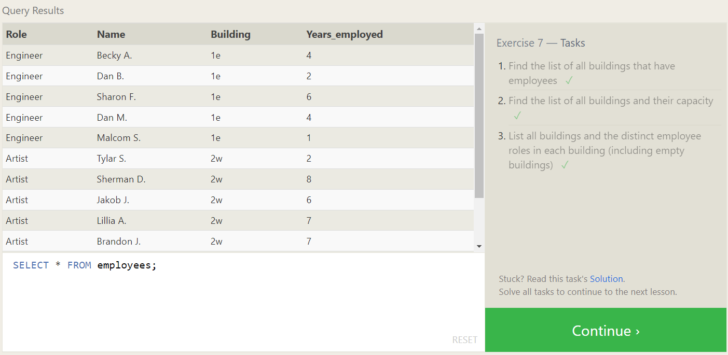

**SQL Lesson 8: A short note on NULLs**

**Exercise 8 — Tasks**

1. Find the name and role of all employees who have not been assigned to a building ✓

* ***SELECT name, role FROM employees WHERE building IS NULL;***

1. Find the names of the buildings that hold no employees ✓

* ***SELECT building_name, name FROM buildings LEFT JOIN employees ON building_name = building WHERE name IS NULL;***

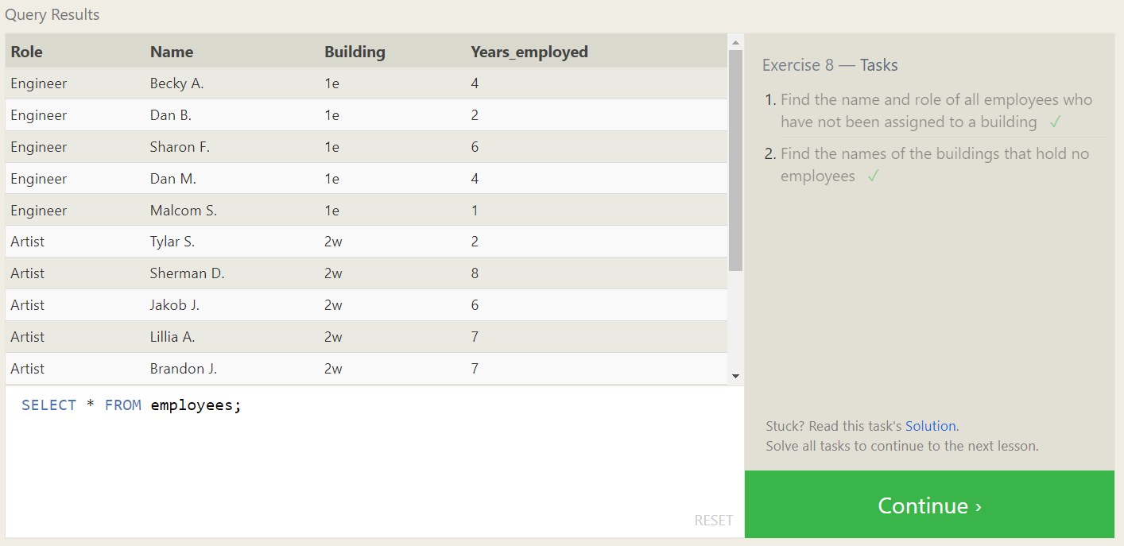

**SQL Lesson 9: Queries with expressions**

**Exercise 9 — Tasks**

1. List all movies and their combined sales in **millions** of dollars ✓

* ***SELECT title, (domestic_sales + international_sales) / 1000000 AS combined_sales_in_millions FROM movies INNER JOIN boxoffice ON movies.id = boxoffice.movie_id;***

1. List all movies and their ratings **in percent** ✓

* ***SELECT title, (rating)*10 AS ratings_in_percent FROM movies INNER JOIN boxoffice ON movies.id = boxoffice.movie_id;***

1. List all movies that were released on even number years ✓

* ***SELECT * FROM movies WHERE year%2=0;***

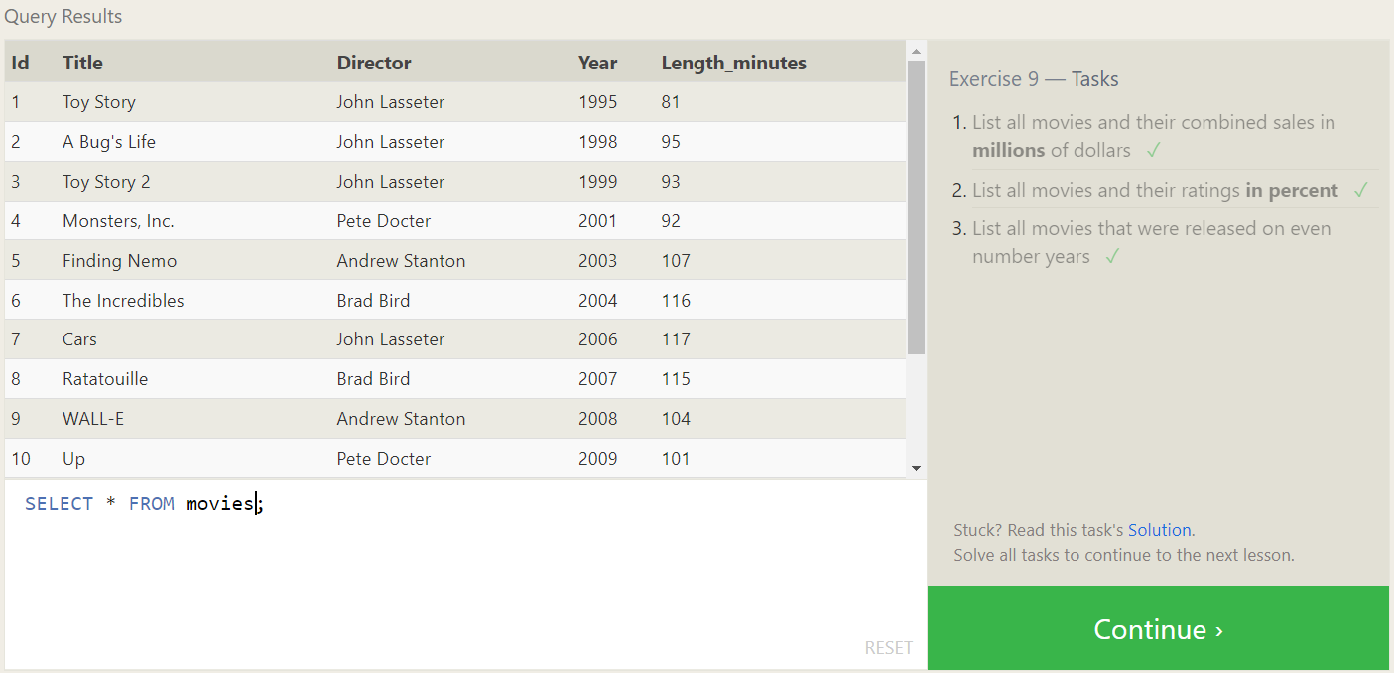

**SQL Lesson 10: Queries with aggregates (Pt. 1)**

**Exercise 10 — Tasks**

1. Find the longest time that an employee has been at the studio ✓

* ***SELECT name, MAX(years_employed) FROM employees;***

1. For each role, find the average number of years employed by employees in that role ✓

* ***SELECT role, AVG(years_employed) FROM employees GROUP BY role;***

1. Find the total number of employee years worked in each building ✓

* ***SELECT building, SUM(years_employed) FROM employees GROUP BY building;***

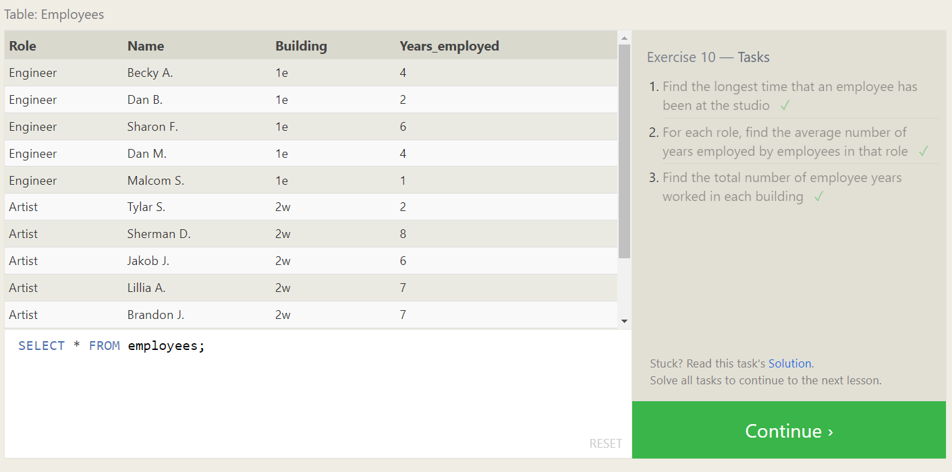

**SQL Lesson 11: Queries with aggregates (Pt. 2)**

**Exercise 11 — Tasks**

1. Find the number of Artists in the studio (without a **HAVING** clause) ✓

* ***SELECT role, COUNT(role) AS number_of_artists FROM employees WHERE role='Artist';***

1. Find the number of Employees of each role in the studio ✓

* ***SELECT role, COUNT(role) AS number_of_employees FROM employees GROUP BY role;***

1. Find the total number of years employed by all Engineers ✓

* ***SELECT role, SUM(years_employed) AS total_number_of_years_employed FROM employees WHERE role='Engineer';***

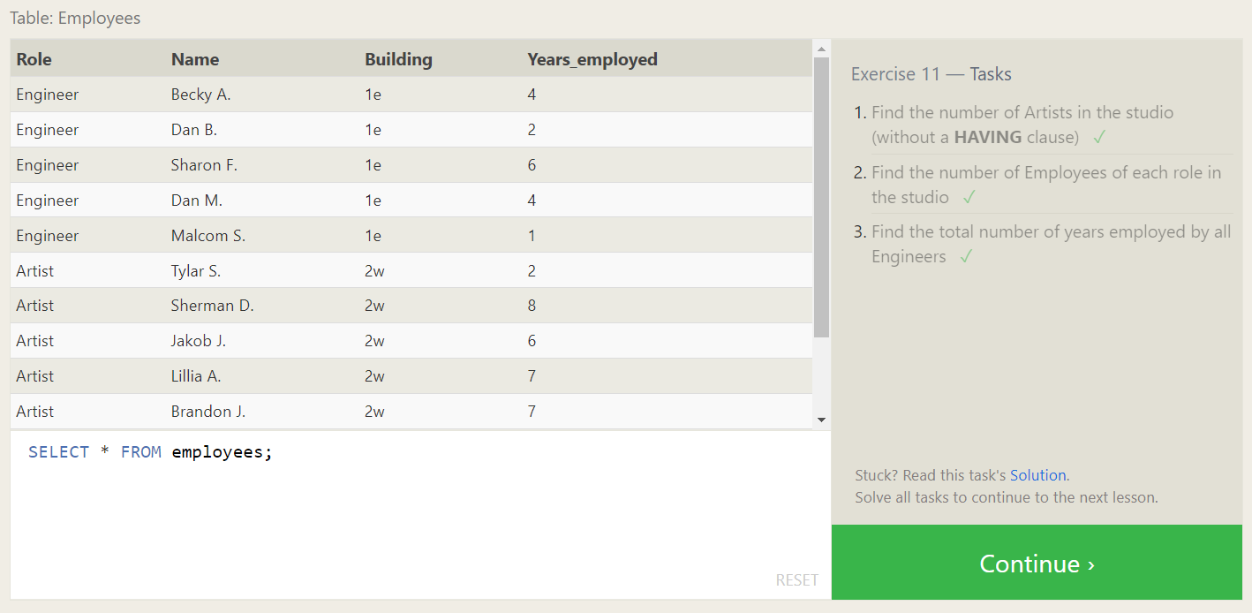

**SQL Lesson 12: Order of execution of a Query**

**Exercise 12 — Tasks**

1. Find the number of movies each director has directed ✓

* ***SELECT director, count(director) AS number_of_movies_directed FROM movies GROUP BY director;***

1. Find the total domestic and international sales that can be attributed to each director ✓

* ***SELECT director, SUM(domestic_sales) + SUM(international_sales) AS total_sales FROM movies INNER JOIN boxoffice ON movies.id = boxoffice.movie_id GROUP BY director;***

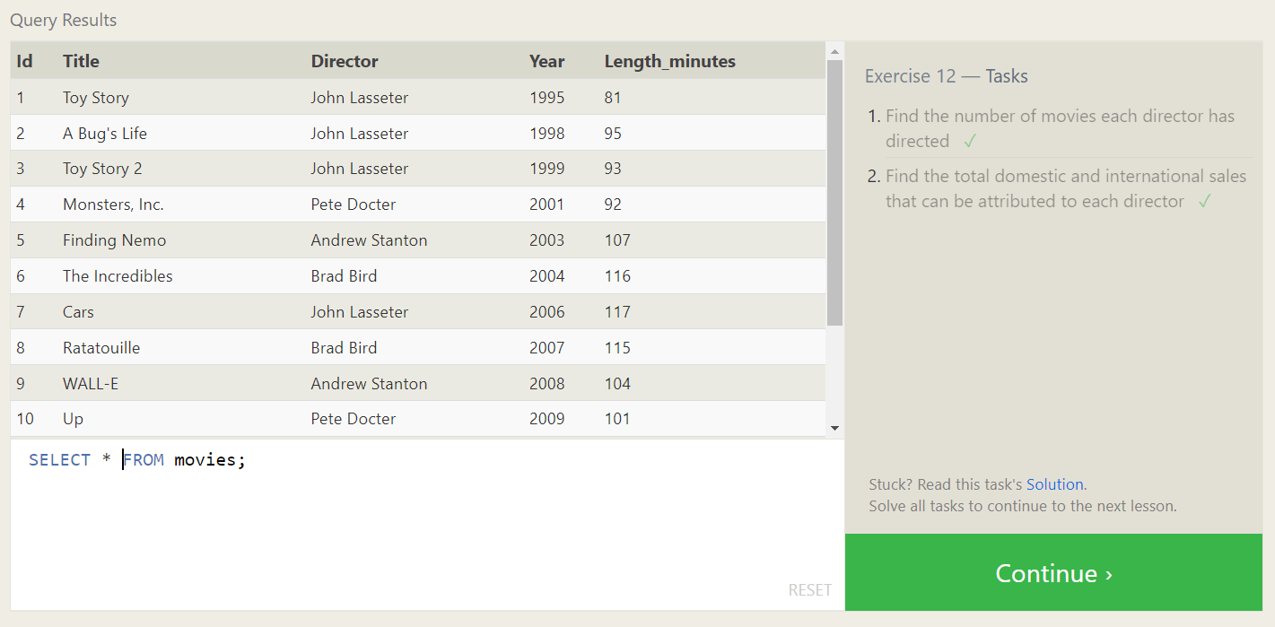

**SQL Lesson 13: Inserting rows**

**Exercise 13 — Tasks**

1. Add the studio's new production, **Toy Story 4** to the list of movies (you can use any director) ✓

* ***INSERT INTO movies (id, title, director, year, length_minutes) VALUES (15, "Toy Story 4", "Josh Cooley", 2019, 100);***

1. Toy Story 4 has been released to critical acclaim! It had a rating of **8.7**, and made **340 million domestically** and **270 million internationally**. Add the record to the **BoxOffice** table ✓

* ***INSERT INTO boxoffice (movie_id, rating, domestic_sales, international_sales) VALUES (15, 8.7, 340000000, 270000000);***

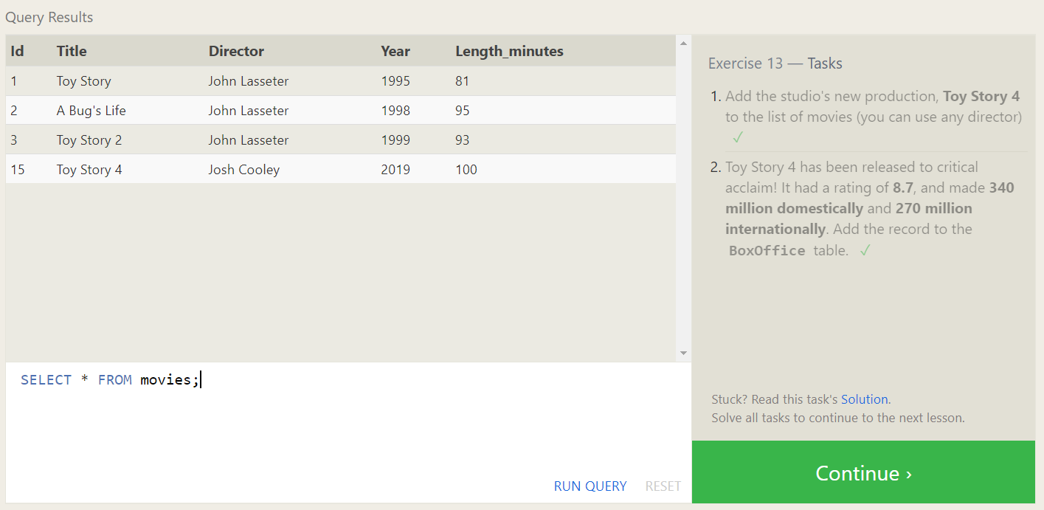

**SQL Lesson 14: Updating rows**

**Exercise 14 — Tasks**

1. The director for A Bug's Life is incorrect, it was actually directed by **John Lasseter** ✓

* ***UPDATE movies SET director="John Lasseter" WHERE title="A Bug's Life";***

1. The year that Toy Story 2 was released is incorrect, it was actually released in **1999** ✓

* ***UPDATE movies SET year=1999 WHERE title="Toy Story 2";***

1. Both the title and director for Toy Story 8 is incorrect! The title should be "Toy Story 3" and it was directed by **Lee Unkrich** ✓

* ***UPDATE movies SET title="Toy Story 3", director="Lee Unkrich" WHERE title="Toy Story 8";***

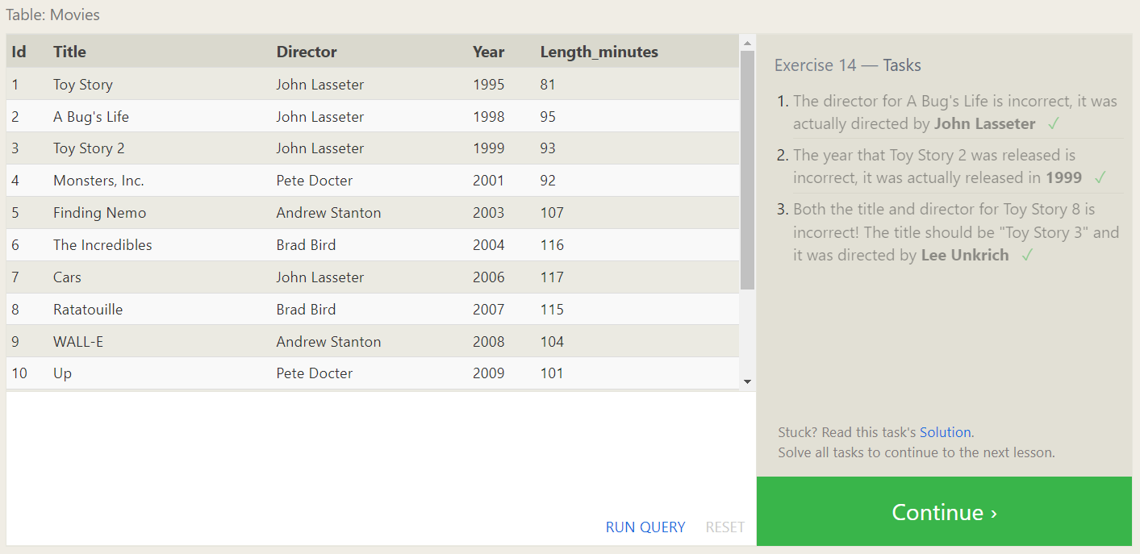

**SQL Lesson 15: Deleting rows**

**Exercise 15 — Tasks**

1. This database is getting too big, lets remove all movies that were released **before** 2005. ✓

* ***DELETE FROM movies WHERE year < 2005;***

1. Andrew Stanton has also left the studio, so please remove all movies directed by him ✓

* ***DELETE FROM movies WHERE director="Andrew Stanton";***

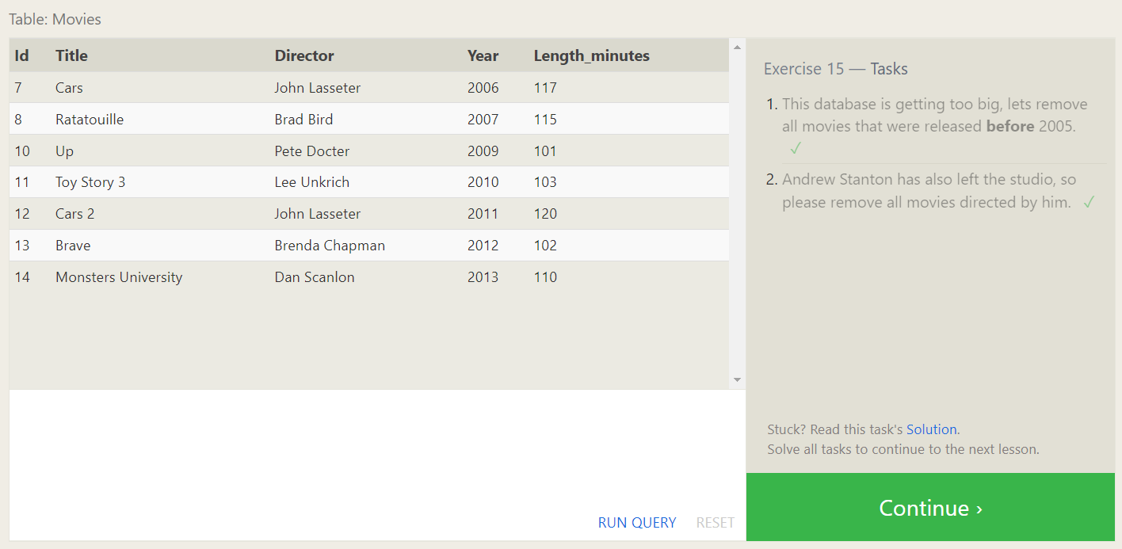

**SQL Lesson 16: Creating tables**

**Exercise 16 — Tasks**

1. Create a new table named **Database** with the following columns:

– **Name -** A string (text) describing the name of the database

– **Version -** A number (floating point) of the latest version of this database

– **Download_count -** An integer count of the number of times this database was downloaded

This table has no constraints. ✓

* ***CREATE TABLE Database (***
* ***Id INTEGER PRIMARY KEY,***
* ***Name TEXT,***
* ***Version FLOAT,***
* ***Download_count INTEGER***
* ***);***

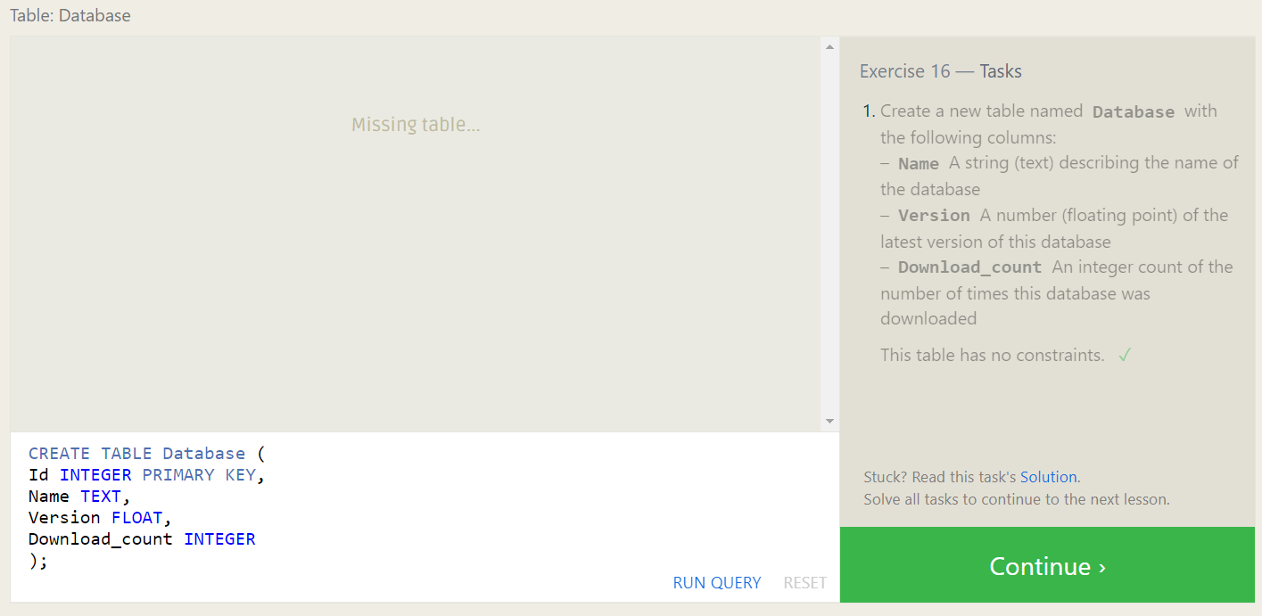

**SQL Lesson 17: Altering tables**

**Exercise 17 — Tasks**

1. Add a column named **Aspect_ratio** with a **FLOAT** data type to store the aspect-ratio each movie was released in. ✓

* ***ALTER TABLE movies ADD Aspect_ratio FLOAT;***

1. Add another column named **Language** with a **TEXT** data type to store the language that the movie was released in. Ensure that the default for this language is **English** ✓

* ***ALTER TABLE movies ADD Language TEXT DEFAULT English;***

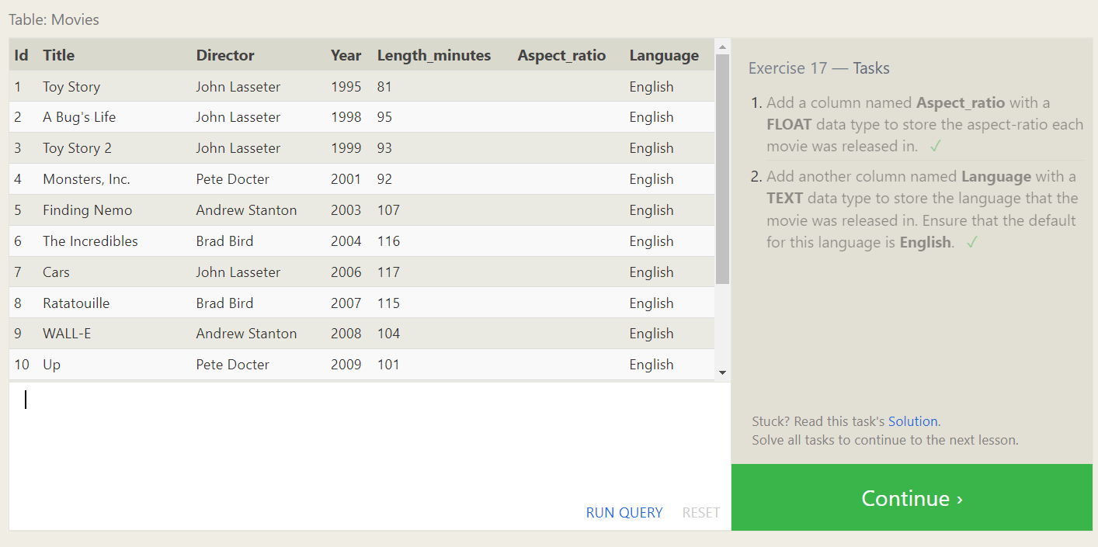

**SQL Lesson 18: Dropping tables**

**Exercise 18 — Tasks**

1. We've sadly reached the end of our lessons, lets clean up by removing the **Movies** table. ✓

* ***DROP TABLE movies;***

1. And drop the **BoxOffice** table as well ✓

* ***DROP TABLE boxoffice;***

